Dan | Ong - Really exciting and interesting work from anthropology about resistance and meaning making in non-western contexts. I found it particularly smart in Ong's discussion of Malaysian worker's understanding of spiritual possession to attempt to reconcile their own beliefs about right physical space and action. Because of the way that the factories of the Japanese (standing in here for the rest of the West) are constructed, located and funded, spiritual possession would make sense as a reaction to hold to disrupt the flow of activity. Rather than seeing this as a disruption due to labor conditions, the biomedical regime would have us ask if people there 'really believe' in were-tigers and spiritual possession and thus breaks down and has to make sense of this phenomena. In this context, it is largely irrelevant if spiritual possession is 'real' or not as we would define it. What is most important is that there is a relationship between well being and well feeling since, "...the spirits were believed to possess women who had violated moral codes...This connection between disturbing spirits and lack of sexual purity is also hinted at in Teoh and his colleagues' account of the school incidents.." (p. 33) In the short run it provides some channel to alert people that there is something wrong with the functioning of work in this way to those who know how to read the cultural signs. However, because we do not and have our own logical system for negotiating and controlling bodies, biomedicalization comes to bear as a way to so silence and suppress what would otherwise be a situation that would HAVE to be rectified in order for work to continue. What is the role then of scientific institutions for making knowledge that allows us to 'run over' other systems of sense making on behalf of economic units? There is something to be said for the way in which knowledge of the body has enabled health disparity, but that it has also allowed for the control of bodies in situtions where a political negotiation might be necessary, especially for these communities sought for their labor.
Colin | I agree with Lyles (2012) that, “In this context, it is largely irrelevant if spiritual possession is 'real' or not as we would define it,” and add to that the ‘argument from common sense’: of course, no, it’s not “real” as we would define it. And that’s why it takes an anthropologist to try and make sense of it for us, back here in the “real, modern world.” Ong divides the possible modes of interpretation thusly:  Anthropologists studying spirit possession phenomena have generally linked them to culturally  specific forms of conflict management that disguise and yet resolve social tensions within  indigenous societies (Firth 1967; Lewis 1971; Crapanzano and Garrison 1977). In contrast,  policymakers and professionals see spirit possession episodes as an intrusion of archaic beliefs into the modern setting (Teoh, Soewondo, and Sidharta 1975; Chew 1978; Phoon 1982). (28)  Are these explanations really all that different? I’m skeptical. The former is what I would label a “functionalist” explanation -- spirit possession performs the function of conflict management: country girls who lack the means to express their dissatisfaction with, in this case, working conditions, (but historically women’s conditions more generally) do so by thrashing about and claiming were-tigers are licking their menses. The latter explanation is also concerned with function -- or more specifically, the lack thereof: some workers are not functioning properly, so we isolate the case, treat it (shoot them up with valium) and send them home. In my opinion, the only real difference between the anthropological explanation and the biomedical one is that the latter only treats symptoms, not the underlying causes. Clearly the factory owners haven’t read Teoh: “epidemic hysteria was not caused by offended spirits but by interpersonal tensions …” (1975:260); and Taussig, who claims“the ‘language’ emanating from our bodies expresses the significance of social dis-ease (1980)” (as quoted in Ong: 34) -- most likely because that’s not part of a middle-manager’s job requirements.  Ong is performing a translation from the culture of female Malaysian factory workers to ours, the one we share with Japanese middle managers. Her prescription, that “spirit beliefs reflect everyday anxieties about the management of social relations in village society,” (31) -- and by extension, social relations in the modern factory setting -- could easily be ported into an executive summary presented to Japanese management: it’s framed in the terms of a paradigm they, (and we) share. The only difference between them and Ong is an interest in the origin/cause of the phenomena: whereas the Japanese see this as countrified ignorance to be cleaned away by bringing in the witchdoctor/bomoh, Ong traces the behavior all the way back to the country, situates it in village practice of conflict management, and then all the way back -- we could take this piece straight to the boardroom, and if they had the time (factory managers are busy people).  In other words, if the “rationality debates” are taking place when “rationality of the West Comes under question from its victims and from the postcolonial world,” (Taussig 1977: 472), I don’t know if this is questioning or reinforcing Western rationality.  So this makes me wonder about Foxconn in China. It would seem that largely the same social transformation is taking place (or has taken place): workers are coaxed by the tens of thousands from the country to the compound -- and made to work. Surely a clever ethnographer could find work translating village-based conflict management practices into a paradigm palatable to upper management?  Ah, maybe I missed this the first time, “This has led him to a powerful auto-critique of the functionalist inclinations of the original essay...” (in re: Taussig’s body of work)  Ah, Taussig is better the second time around:  “Rather than man being the aim of production, production has become the aim of  man and wealth the aim of production; rather than tools and the productive  mechanism in general having liberated man from the slavery of toil, man has become  the slave of tools and the instituted processes of production.” 479  Spirits of Resistance - Ch 1 http://libcom.org/library/intellectuals-power-a-conversation-between-michel-foucault-and-gilles-deleuze
Michael | I found the cultural capital piece by Lamont and Lareau (L&L) particularly interesting, when placed in conversation with Hossfeld’s work on the contradictions of sex race and class in Silicon Valley. L&L call for a focus on cultural capital that identifies the “institutionalized repertoire of high status cultural signals and to conflicts around symbolic boundaries” (164). Hossfeld’s work, I would argue maintains the “micro-political dimension” of cultural capital while also attending to how the women workers in the semiconductor manufacturing context constructed and subverted feminine boundaries of belonging to their advantage. The section of Hossfeld’s article, which highlights the role of “femininity” in the workplace nicely balances the high status signals of cosmetics, with the agency of the women workers. The role of “compensating” here is of particular importance when considering the capitalist logic of gender and how that logic can be used against managers, etc.  “I told him that the solvent would ruin my manicure, and I’d be a mess for the wedding. Can you believe it? He let me off the work! This guy wouldn’t pay attention to my rash, but when my manicure is at stake, he let me go” (11).  The authors conclude that while these are short-term benefits, that ultimately, reinforce patriarchal capitalism in the long term.  I also found the cultural capital piece to speak particularly well to “New Voices on the Net?,” which focused on the exclusion of networks and thinking about minority participation in media production. Cultural capital is a term that was often used during professional development with DYN. We, as mentors, were viewed as providing youth with the cultural capital to participate in emerging literacy practices. However, the term was never used in the context of exclusion. As I read L&L’s article, I continually stopped to think about how my own practices as a media educator were at one time allowing students to access “high status” signals, while reproducing the exclusionary trend of “symbolic dominance” (160).
db | 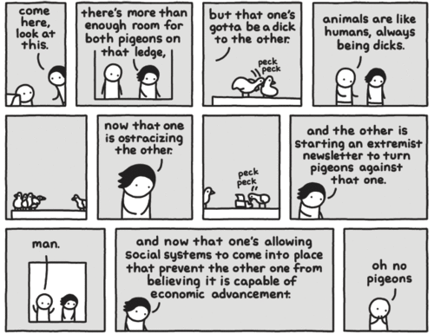  I’m tempted to ask the class to imagine effective ways of using all of the readings to craft effective activism and resistance in the American context but I would understand if that’s not everyone’s cup of tea.  I would like us to spend a little time carefully unraveling Taussig’s analogies. I think I was pretty good at them on the SATs but I got a little lost in them this time. Specificially, I had a hard time parsing this pair: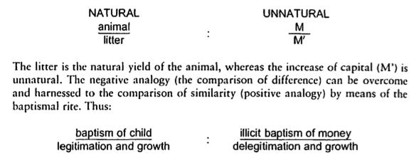  From the Ong piece, I thought we could carefully sidestep the temptation to mind read and figure out what the female factory workers are “really” thinking and instead use this as an opportunity to talk about and problematize the concept of modernity. Modernity doesn’t look the same in all countries and, as Dan noted above, changing specific parts (i.e. biomedical regimes) can be empowering for workers. instead of trying to get into the worker’s heads we can try to parse out the boundaries that are formed when agents break the monolith of modernity. Can Lamont and Lareau help us here? Does it aid us in any way to talk about the Malaysian workers (or the Silicon Valley workers, or the South American farmers) as gaining the upper hand through inverting/subverting/ignoring the hegemonic cultural distinctions that typically aid in their oppression?  Is a “spirit” a referent for something that our culture has no word for? A social “object” that sounds mystical or “unreal” but might help individuals talk about social relations?
Jalynn  Jalynn | Aihwa Ong’s article was interesting. He presents a cultural phenomenon drawing from different perspectives. Directly quoting the text “In the early 1970’s, when young peasant women began to leave the Kampung and enter the unkown worlds of urban boarding schools and factories, the incidence of spirit possession seems to have become more common among them than among married women”. However, reading between the lines you can sense the author’s skepticism of actual spirit possession. He tries to explain it with the difficulties facing a woman entering the workforce far from home. Their work environment is presented as far from ideal. Directly from the text, “These include the rapid deterioration of eye sight caused by the prolonged use of microsocpes in bonding processes. General exposure to strong solvents, acids, and fumes induced headaches, nausea, dizziness, and skin irritation in workers.” Also, he presents the company protocol as a way to respect people’s beliefs while also getting work production accomplished. Also directly from the text, “Both Japanese factories in Kuala Langat have commenced operations in a spate of spirit possession incidents. A year after operations began in the EJI factory, as well-known bomoh and his retinue were invited to the factory surau, where they read prayers over a basin of “pure water”.  Karen J Hossfeld’s article is interesting. She presents the all too common story of the working woman whom has a family to support on minimum wages. However, Karen goes a step forward and speaks to the separation of labor. She tells of how women are restricted from better paying jobs because of racism and sexism. She tells of instances of some women doing the same kind of work as their male counterparts but getting less pay. I agree with her opinion that management uses race and gender to their advantage as it fits their ulterior motives. Quoted directly from the text “When a man expresses special needs that result from his structural position in the family-such as head of the household-he is often “compensated,” yet when a woman expresses a special need resulting from her traditional structural position in the family-child care or her position as head of household-she is told that such issues are not of concern to the employer” And Karen portrays the various tactics used by these hard working women. It is admirable that they can still negotiate change under such hostile conditions. The background information about the industry of silicon valley is also interesting.  There is famous speech performed by Sojourner Truth titled “Ain’t I a woman”  Sojourner Truth was an African -American woman, a former slave whom became an abolitionist. She was an extraordinary speaker.
Pedro | 1. Ong’s piece was very interesting. I thought there might be an interesting tension to explore between possession as a form or rebellion and agency, and possession by definition (and, one would assume, experience) as the suspension of agency.  I was also left wanting to know more about the priests hired by the factories. Ong says that “the work of the bomoh was further thwarted by the medicalization of the afflicted” (39). But they were hired to appease workers in such a way that major changes would not have to be made, and I wonder how they negotiated this tension.  2. Taussig is probably right:    There seems to me something very powerful and accurate about the idea of commodity fetishism, but opposing a real economy of social relations with a virtual, make-believe market possessed by bullish and bearish spirits is now somewhat taboo, and for some good reasons. Plus, nowadays people seem to really like to regard things “as though they are indeed animate things,” although now they seem animate because they are seen as “system of relations” (482).  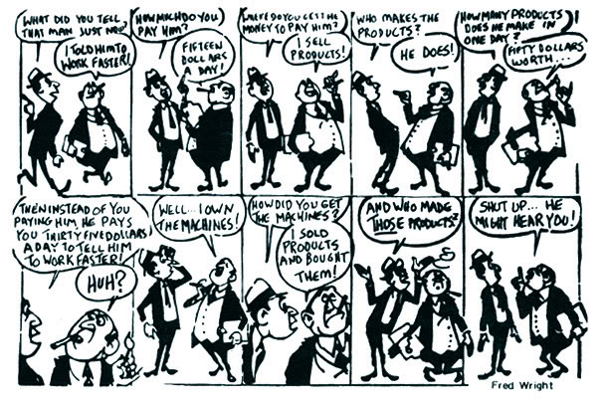
Ellen | I found Taussig’s account of workers within South America using imagery and rituals to critique and demonstrate the implications and morales behind capitalism as quite interesting.  -The contract with the devil scenario (when working on plantations, not on one’s own or neighbor’s lands) is an interesting spin on how to make a profit in the sense that capitalism wants there to be a profit in the exchange value system that contradicts the worker’s own use value-system.  -The example that really struck me was the baptizing of money scenario. The very idea that you can give life/soul to the money in a sense that it takes on a life of it’s own to procreate and replicate is intriguing.  I also liked Taussig’s relation of the Newtonian gravitational and atomized system as in tune and parallel to the capitalistic world as interesting. In contrast he shows that the value system has a system based on Aristotelean concepts (if I am interpreting all this correctly) and that, “This reasoning appears to derive from a concept of the universe as an interrelated organism which is understood through the conscious application of animistic analogies,”  Thus one has capitalism not viewed as natural, but instead against the cosmic order and the animus system in a sense.  Also, in terms of this Aristotelian vs Newtonian system as relating to use-value vs exchange value systems, is this something that comes up in Mark or Weber or elsewhere? Just curious.  http://ebookcollective.tumblr.com/post/30486096214/kropotkins-revolutionary-pamphlets-a-collection-of

